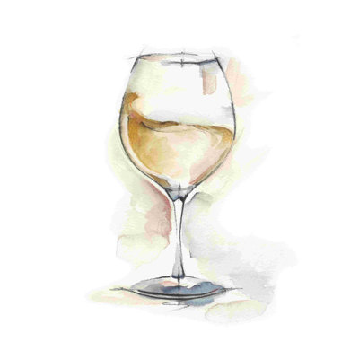
PALM WORTH LADIES PAINT AND SIP PARTY
INSTRUCTOR: ANN HOBSON
DATE: TUESDAY, MARCH 3
TIME: 7:00 – 9:00
LOCATION: PALM WORTH CLUBHOUSE
PRICE: $25.00 PER PERSON
LIMITED TO 15 PARTICIPANTS
- Drop $$ off to Deb Sergeant #407 or Venmo Debra-Sergeant
RSVP by Friday, February 27. Sign up on the bulletin board outside the laundry room or text Deb Sergeant at 732-533-7411.

NO PRIOR ARTISTIC SKILL IS EXPECTED OR REQUIRED!!
Included in the $25 fee:
- All supplies will be provided: paint, brushes, canvases, easels, paint trays, gloves, water cups and tablecloth protectors.
- Step-by-step instructions.
- A beautiful, finished piece of artwork to take home!

What can you bring?
- Wine or another beverage of your choice.
- Any additional snacks you might want to share
- An apron or smock to protect your clothing! Wear casual and comfortable clothing that allows you to move freely and sit comfortably.

