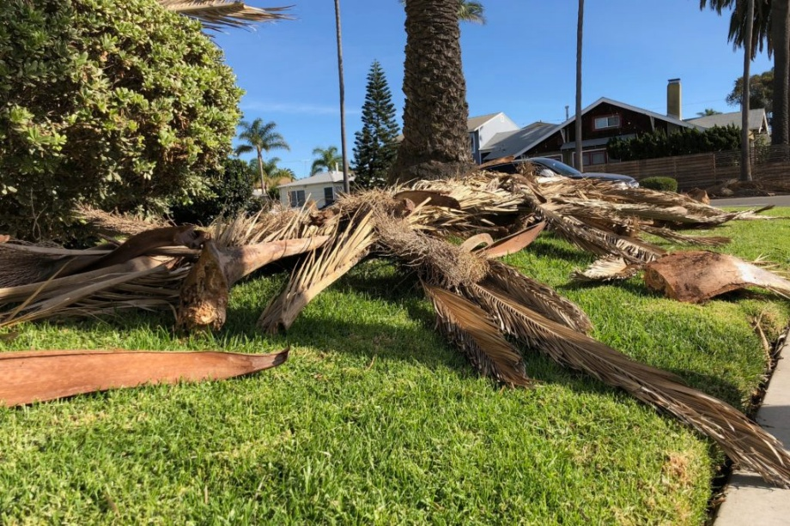

To All Shareholders:
If you see any orange cones placed around Palm Worth, please do not move them. When the cones are placed outside that is a safety precaution to look up while walking as we don’t want anyone to get hit by any falling fonds or other debris that may hit the ground due to strong winds. We thank you for your cooperation.

Kind regards,
Management

