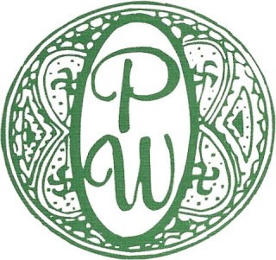
Palm Worth
Request for Unit Modification Approval

Date _________________________
Name ________________________ Phone Number _______________________
Unit # ________ Email Address _______________________________________
Email application to: Palmworth2850@gmail.com

Per Palm Worth’s bylaws page 28, article 20;
The shareholder or occupant of any cooperative unit agrees not to make any structural
alterations in or additions to any unit, or any changes, alterations, or additions in or to the exterior of said buildings, or any structure change of the interior thereof. Such changes shall include, but shall not be limited to, changes in exterior doors, windows, air conditioners, balconies or in the color or design thereof, except with the prior written consent in each case of the Board of Directors of the corporation, and where required, the permission of the appropriate authorities of the Town of Palm Beach and where required, shall furnish the Board with a copy of a building permit and engineering drawings certifying that the alterations to be executed will not impair the structural integrity of the building.

Please refer to Unit Modification Regulations for a list of required information
to be submitted with this request.

Brief Description: In the space below, or on an attached page, please give a detailed description of the alteration, improvement, addition or other change you are requesting to make to your unit.
__________________________________________________________________________________________________________________________________________________________________________________________________________________________________________________________________________________________________________________________________________________________________________________________________________________________________________________________________________________________________________________________________________________________________________________________________________________________________________________________________________________________________________________________________________________________________________________________________________________________________________
I have read and understand the Palm Worth Unit Modification Regulations and agree to comply fully with all rules and guidelines related to this modification request. I have provided my contractor with a copy of the attached construction regulations and instructed them to review and adhere to them.
Furthermore, I acknowledge that the Board of Directors and/or Property Manager reserves the right to halt any installation or construction at any time—at the shareholder’s expense—if the work being performed deviates from what has been approved in this application.

Print name ________________________________
Signed ___________________________________ Date ____________________________

___ Approved by the board of directors
___ Approved subject to the following conditions; ____________________________________________________________________________________________________________________________________________________________
___ Pending, insufficient information, resubmit requested information
___ Denied, not approved for the following reason;
____________________________________________________________________________________________________________________________________________________________

Board of Directors Date ___________________

